

**Ain Shams University**  
**Faculty of Computer & Information Sciences**

**Computer Science Department**

Eye Guide

(Virtual Assistant for The Blinds)

**

**July 2022**



**Ain Shams University**  
**Faculty of Computer & Information Sciences**

**Computer Science Department**

Eye Guide

*(Virtual assistant for the blinds)*

**By:**

David Maged [CS]

Joseph Ezzat [CS]

Ibrahim Sayed [CS]

Haya Hesham [CS]

Marlin Magdy [CS]

**Under Supervision of:**

[Dr/ Salsabil Amin]

[Lecturer]

Basic Science Department,

Faculty of Computer and Information Sciences,

Ain Shams University.

[Dr/ Mona Sadek]

[Teaching Assistant]

Computer Science Department,

Faculty of Computer and Information Sciences,

Ain Shams University.

# 

# Acknowledgment

The success and outcome of the project required a lot of guidance and assistance from many people, and we would like to express our special thanks of gratitude to **Dr. Salsabil Amin** for allowing us to do this project and for giving us all the help and support we needed along with the completion of the project.

We would also want to thank **TA Mohammed Essam** and **TA Mona Sadek** for their time and effort and for giving us a good guideline for the project throughout numerous consultations.

This project wouldn’t be completed without the effort and cooperation of all the team members.

Finally, we would like to thank our friends, family, and everyone that helped us directly or indirectly to complete this project.

# List of Abbreviations

# YOLO: You Only Look Once

# CNN: Convolutional Neural Networks

# DL: Deep Learning

# AI: Artificial Intelligence

# ReLU: Rectified Linear Unit

# SSD: Single Shot Multi-Box Detector

# R-CNN: Region-based Convolutional Neural Networks

# IoU: Intersection over Union

# FPS: Frames Per Second

# API: Application Programming Interface

# HOG: Histogram of Oriented Gradients

# SVM: Support Vector Machine

**ML:** Machine Learning

**EGP:** Egyptian Pound

**ANN:** Artificial Neural Networks

**NN:** Neural Networks

**SGD:** Stochastic Gradient Descent

**OCR:** Optical Character Recognition

**RGB:** Red-Green-Blue

# Abstract

Visually impaired people move around based on their senses and experiences with the aid of guidance aid to detect and avoid collisions with objects and overtaking obstacles. After conducting our research, we found so many applications each one only does one task, so visually impaired people will have to switch from one application to another which is very difficult to do and live a normal life. So, we decided to make one application that will have all the basic features the visually impaired people will need in their everyday life. And we built a mobile application that contains four features, Object recognition which has an accuracy of 97%, Face recognition which has 95%, Currency recognition which has 87%, and OCR. Our application is voice-guided, so the user won’t have to tap any button. Life is hard for visually impaired people; we hope our project helps make their routine a little bit easier.

**Contents**

Abstract i

List of Figures iii

1- Introduction 1

1.1 Motivation 1

1.2 Problem Definition 1

1.3 Objective 1

1.4 Time Plan 2

1.5 Document Organization 2

2- Background 3

3- Analysis and Design 12

3.1 System Overview 12

3.1.1 System Architecture 12

3.1.2 System Users 13

3.2 System Analysis & Design 13

3.2.1 Use Case Diagram 13

3.2.3 Sequence Diagram 14

4- Implementation and Testing 15

5- User Manual 37

6- Conclusion and Future Work 38

6.1 Conclusion 38

6.2 Future Work 38

References 41

# List of Figures

|  |  |
| --- | --- |
| **Figure 1-Project Time plan ………………………………………………….** | **2** |
| **Figure 2-Neural-Network general architecture…………………………….** | **4** |
| **Figure 3- Convolution Operation ……………………………………………** | **5** |
| **Figure 4- Pooling layer architecture.………………………………………** | **6** |
| **Figure 5-RelU Output …….……………….…………………………………** | **7** |
| **Figure 6-Max pooling function output .……………………………………** | **7** |
| **Figure 7-Artificial Neural network with fully connected layers …………** | **8** |
| **Figure 8-Yolo Design …….……………….………………………………….** | **9** |
| **Figure 9-Bounded box parameters.…………………………………………** | **10** |
| **Figure 10-YOLO Output ….…………………………………………………** | **11** |
| **Figure 11-EYE Guide System Architecture ……………………………….** | **12** |
| **Figure 12-Eye Guide use case diagram …….………………………………** | **13** |
| **Figure 13-Eye Guide Sequence diagram ….……………………………….** | **14** |
| **Figure 14-YOLO convert image to grid ….…………………………………** | **17** |
| **Figure 15-YOLO output grid ….…………………………………………...** | **18** |
| **Figure 16-Anchor grid ….…………………………………………………..** | **18** |
| **Figure 17-IoU Operation ….………………………………………………..** | **19** |
| **Figure 18-Before and after non maximum suppression…………………..** | **19** |
| **Figure 19-Object detection neural network model………………………….** | **20** |
| **Figure 20-Object detection output example ….……………………………** | **21** |
| **Figure 21-flowchart of face detection ….……………………………………** | **22** |
| **Figure 22-Face detection technique ….………………………………………** | **23** |
| **Figure 23-HOG image ….…………………………………………………….** | **24** |
| **Figure 24-Face detection output ….…………………………………………** | **25** |
| **Figure 25-detect eyes and lips ….……………………………………………** | **25** |
| **Figure 26-Face encoding ….…………………………………………………** | **26** |
| **Figure 27-Face detection output ….…………………………………………** | **27** |
| **Figure 28-Add new person ……….….………………………………………** | **28** |
| **Figure 29-CNN internal implementation ….……………………………….** | **33** |
| **Figure 30-Transfer Learning concept ….…………………………………..** | **34** |
| **Figure 31-Mean Average Precision ….……………………………………..** | **34** |
| **Figure 32-Precision ….………………………………………………………** | **34** |
| **Figure 33-Recall ….………………………………………………………….** | **35** |
| **Figure 34-Currency Recognition output ….………………………………..** | **35** |
| **Figure 35-OCR Input & Output ….…………………………………………** | **36** |
| **Figure 36-Eye Guide home screens ….………………………………………** | **37** |
| **Figure 37-Eye Guide Models Screens ….……………………………………** | **38** |
| **Figure 38-Focal Length Representation ….…………………………………** | **39** |
| **Figure 39-Focal Length Algorithm ….………………………………………** | **39** |
| **Figure 40-Image captioning model ….………………………………………** | **40** |
| **Figure 41-Project URL …………...….………………………………………** | **43** |

# Introduction

## **1.1 Motivation**

Our App Targets blind people.

What Motivates Us?

1. Help them enjoy their life.
2. Help them to be more independent.
3. Help them navigate outdoors safely.
4. Relieve them from feeling that they are burdens on other people or family members all the time.

## **1.2 Problem Definition**

1. According to the world blind union, there are about 253 million people around the world with serious vision problems.
2. There are about 47 million of them who are blind.
3. Visually impaired people can sense light and shadows only and cannot see objects in front of them.
4. Visual impaired and blind people frequently do not detect or recognize outdoor obstacles.
5. Eye Guide will help the visually impaired and the blind people in an outdoor environment without depending on other people.

## **1.3 Objective**

1. Build an image processing app to help recognize everyday use objects, and people.
2. Build a voice translator feature to help visually impaired people enter their commands.
3. Build a navigation system to help visually impaired people work around without any help.

## **1.4 Time Plan**

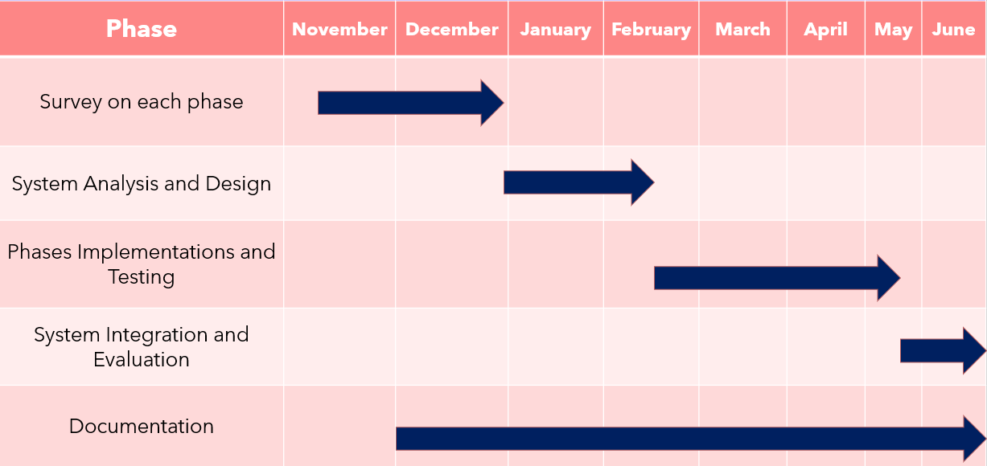

*Figure 1: Time Plan*

## **1.5 Document Organization**

* ***Chapter 2: Background:-***

This chapter includes a detailed description of the field of the application, techniques used, algorithms, and a scientific background related to this field. As well as a description of existing similar systems.

* ***Chapter 3: Analysis and Design: -***

This chapter includes an overview of the system, which contains a system architecture, and a description of the system users. Additionally, the chapter includes illustrative diagrams: a use case diagram, a sequence diagram, and a database diagram.

* ***Chapter 4: Implementation and Testing: -***

This chapter includes a detailed description of all the functions in the system, all techniques and algorithms implemented, all the technologies used, and how the testing was performed.

* ***Chapter 5: User Manual: -***

This chapter includes a detailed description of how to operate the system along with screenshots of the system representing all steps

* ***Chapter 6: Conclusion and Future Work: -***

This chapter includes a complete summary of the whole system along with the results obtained and what can be done in the future to improve the performance of the system and all the additional functions it can be added.

# Background

**2.1 Description of fields of our system.**

Our field is dependent on the main concepts of Neural Networks and Deep learning also we use a flutter framework to develop the mobile app.

We work on our project using a lot of deep learning concepts and libraries like:

1. **Deep Learning concepts:**

* Convolution Neural Network (CNN).
* Yolo Architecture for object detection.

1. **Libraries Used:**
   * Open CV Library.
   * Face Recognition Library.
   * TensorFlow.

**2.1 Deep Learning**

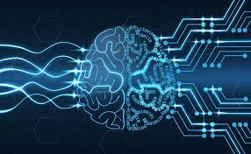

Deep learning is a subset of [machine learning](https://www.ibm.com/cloud/learn/machine-learning), which is essentially a neural network with three or more layers. These neural networks attempt to simulate the behavior of the human brain—albeit far from matching its ability—allowing it to “learn” from large amounts of data. While a neural network with a single layer can still make approximate predictions, additional hidden layers can help to optimize and refine for accuracy.

Deep learning drives many [artificial intelligence (AI)](https://www.ibm.com/cloud/learn/what-is-artificial-intelligence) applications and services that improve automation, performing analytical and physical tasks without human intervention. Deep learning technology lies behind everyday products and services (such as digital assistants, voice-enabled TV remotes, and credit card fraud detection) as well as emerging technologies (such as self-driving cars).

**How it works:**

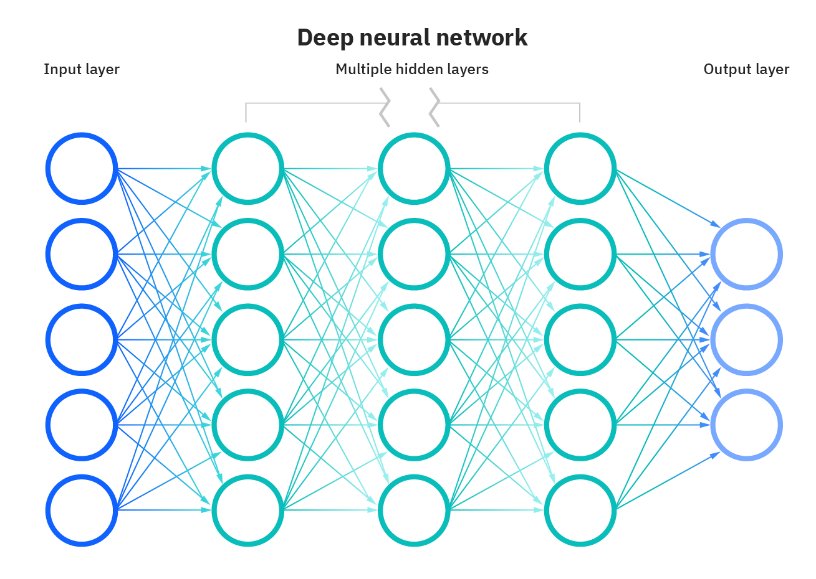

*Figure 2: Neural Network General Architecture.*

Deep learning networks learn by discovering intricate structures in the data they experience. By building computational models that are composed of multiple processing layers, the networks can create multiple levels of abstraction to represent the data.

Deep learning has evolved together with the digital era, which has brought about an explosion of data in all forms and from every region of the world.

This data, known simply as big data, is drawn from sources like social media, internet search engines, e-commerce platforms, and online cinemas, among others. This enormous amount of data is readily accessible and can be shared through fintech applications like cloud computing.

However, the data, which normally is unstructured, is so vast that it could take decades for humans to comprehend it and extract relevant information. Companies realize the incredible potential that can result

from unraveling this wealth of information and are increasingly adapting to AI systems for automated support.

**In Our project,** we are using deep learning in a lot of models Like,

**2.3.1 Convolution Neural Network (CNN).**

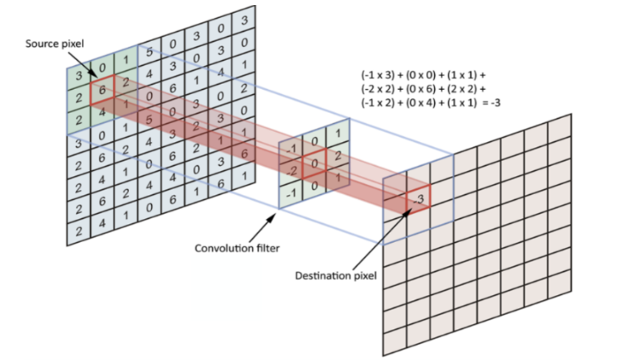

*Figure 3: Convolution Operation.*

* Convolutional layers are the layers where filters are applied to the original image, or other feature maps in a deep CNN,
* This is where most of the user-specified parameters are in the network. The most important parameters are the number of kernels and the size of the kernels.

**Pooling Layers**

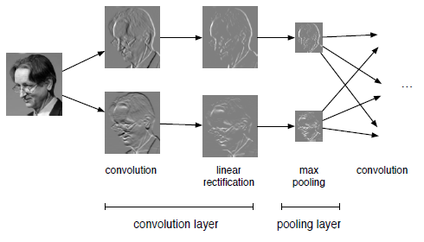

*Figure 4: Pooling Layer Architecture.*

Pooling layers are like convolutional layers, but they perform a specific function such as max pooling, which takes the maximum value in a certain filter region, or average pooling, which takes the average value in a filter region.

 These are typically used to decrease the dimensionality of the network or increase it.

Pooling layers are like convolutional layers, but they perform a specific function such as max pooling, which takes the maximum value in a certain filter region, or average pooling, which takes the average value in a filter region.

These are typically used to decrease the dimensionality of the network or increase it.

**RelU Activation Function**

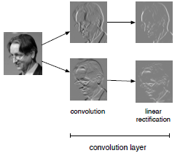

*Figure5: RelU Output.*

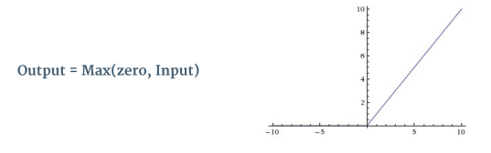

*Figure6: Max Pooling Function Output.*

* Convolution is a linear operation.
* Therefore, we need a **non-linearity**, otherwise 2 convolution layers would be no more powerful than 1.
* ReLU has been used after every Convolution operation.

**Fully Connected Layers**

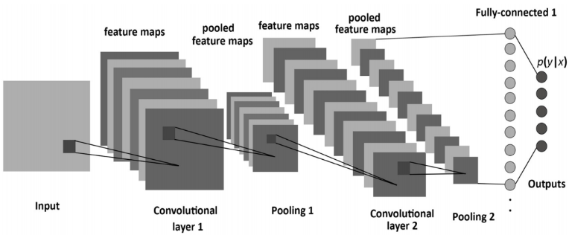

*Figure7: Artificial neural network with fully connected layers.*

Fully connected layers are placed before the classification output of a CNN and are used to flatten the results before classification. This is like the output layer of an MLP.

**2.3.2 You Look Only Once (YOLO)**

Yolo is an object detection algorithm that divides images into a grid system. Each cell in the grid is responsible for detecting objects within itself.

It is one of the most famous object detection algorithms due to its speed and accuracy.

**YOLO Design:**

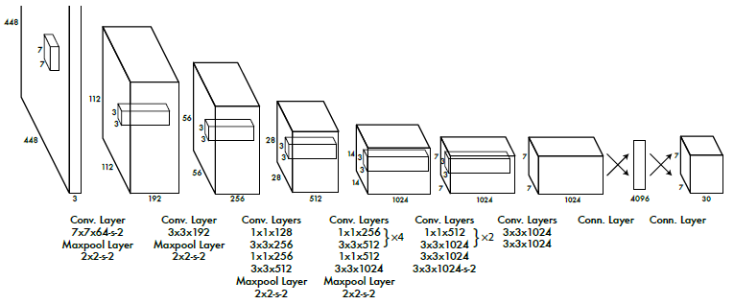

*Figure8: YOLO Design.*

The YOLO Detection network includes:

* 24 Convolutional layers.
* 2 Fully connected layers.

**How it works?**

1. Divide the image into an S*S grid, If the center of an object falls into a grid cell, the cell is responsible for detecting that object.
2. Each grid cell predicts B boxes(x,y,w,h) and confidences of each box P(Object). P(Object): probability that the box contains an object

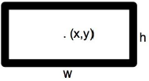

*Figure 9: Bounded box parameters*

1. Each grid cell also predicts C conditional class probabilities (conditioned on the grid cell containing an object) (Class Scores). As: **Pr(Class*i*|Object)**.

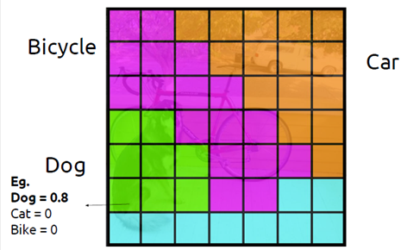

1. **Then combine the box and class predictions:**

**Pr(Class*i*|Object)*P(Object) = P (Class)**

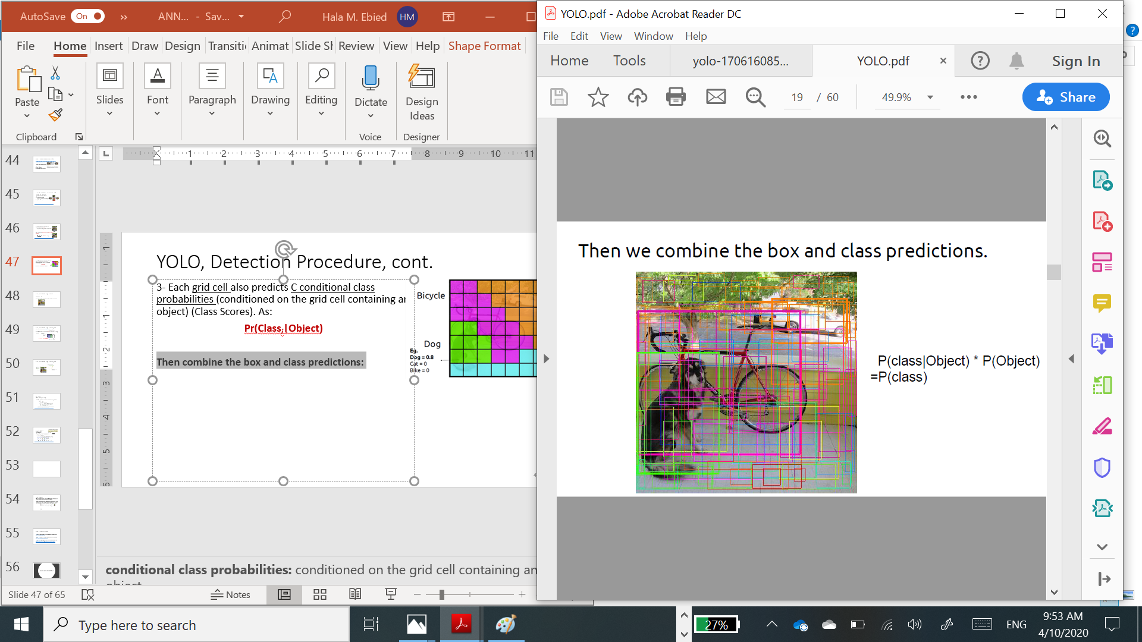

5. **Finally do threshold detections and** **Non-Maximum Suppression (NMS)**

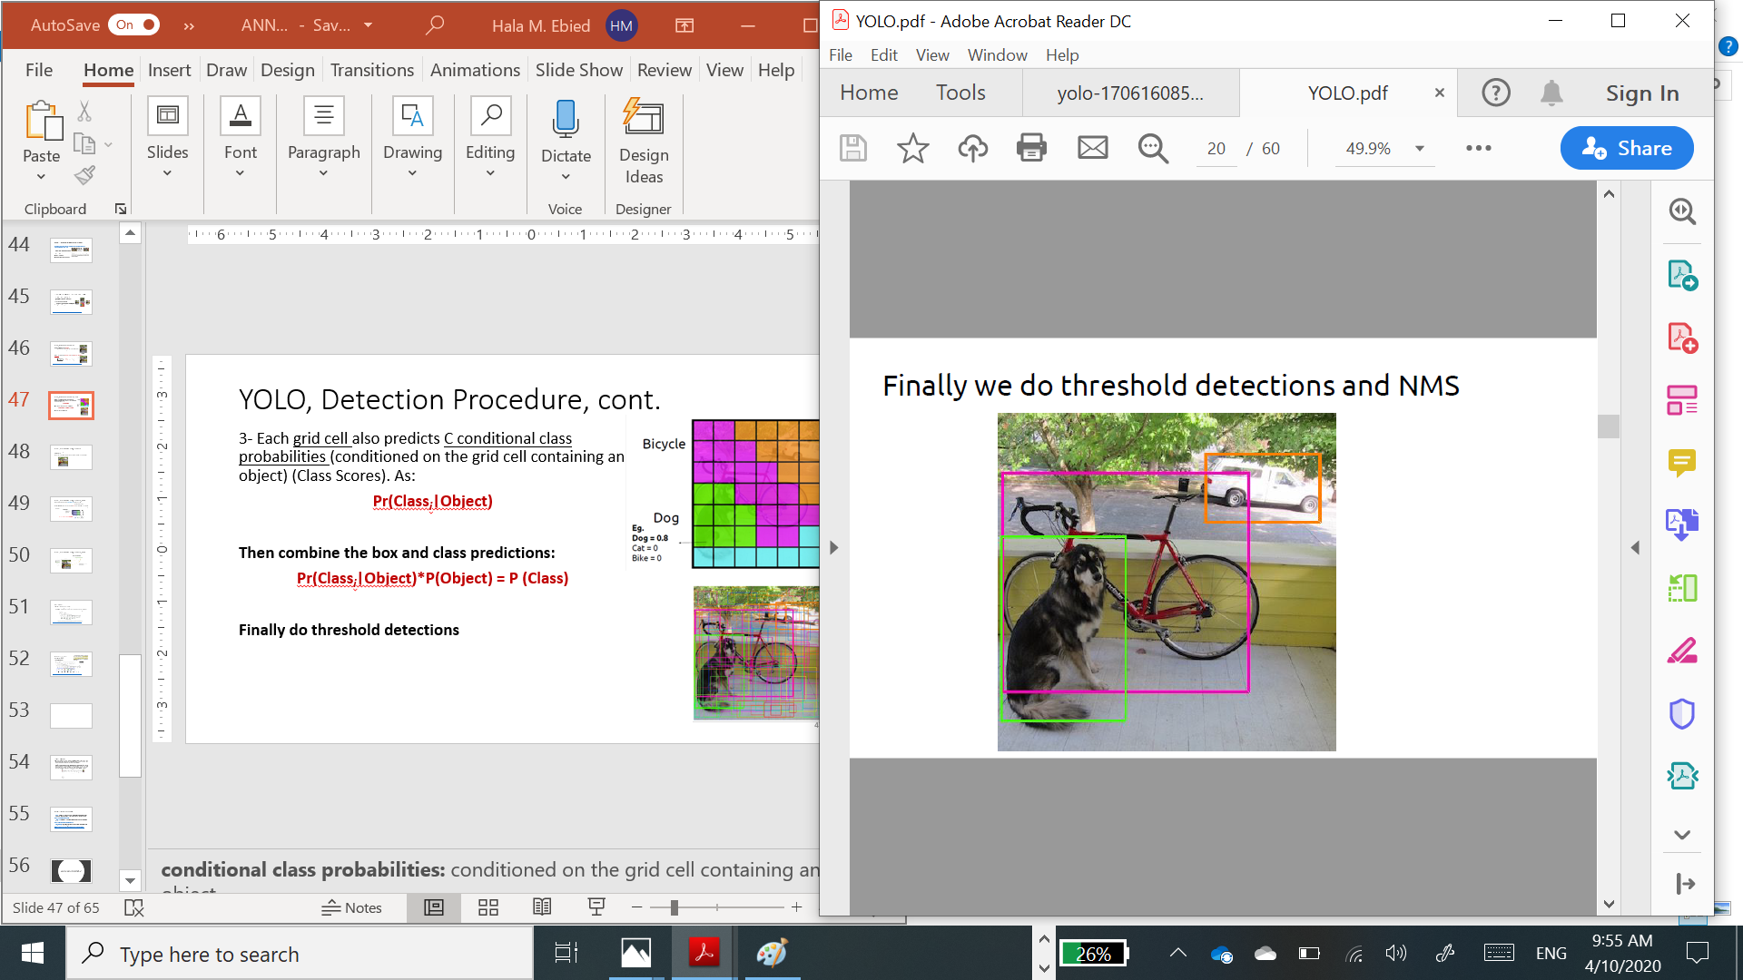

YOLO final output if:

S: Grid Size.

B: Number of bounding boxes to be predicted.

C: Number of class probabilities.

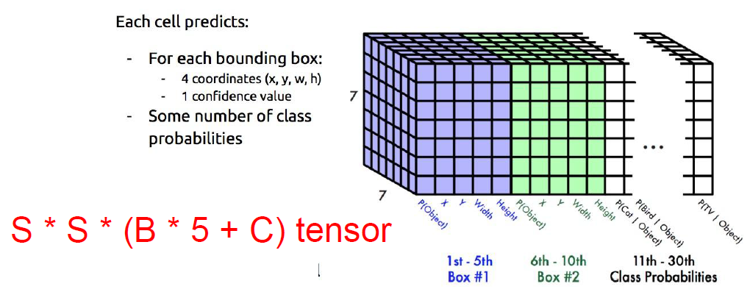

*Figure 10: YOLO Output.*

# Analysis and Design

## **3.1 System Overview**

### **3.1.1 System Architecture**

**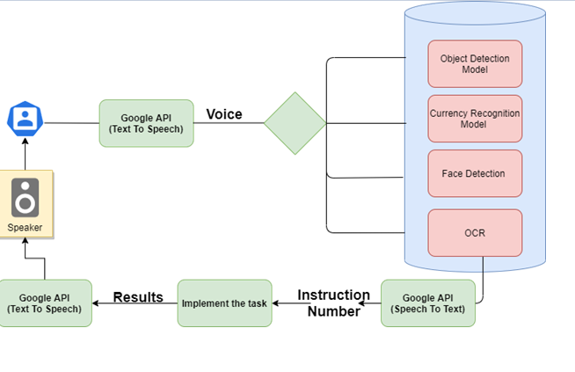

*Figure 11: EYE Guide System Architecture.*

1. Our system will start by telling the user the instructions using Google text to speech API.
2. The user will say the instruction number and a Google Speech to text API Will receive the instruction.
3. The API will send the Instructions number to the system to be implemented.
4. The results will be sent to Google Text to Speech API and then to the speakerphone.

### **3.1.2 System Users**

1. *Intended Users:*

For Blind people and any person having a problem with the vision.

1. *User Characteristics*

What users need is a mobile phone supports Android Operating system (+10 version).

## 3.2 **System Analysis & Design**

### **3.2.1 Use Case Diagram**

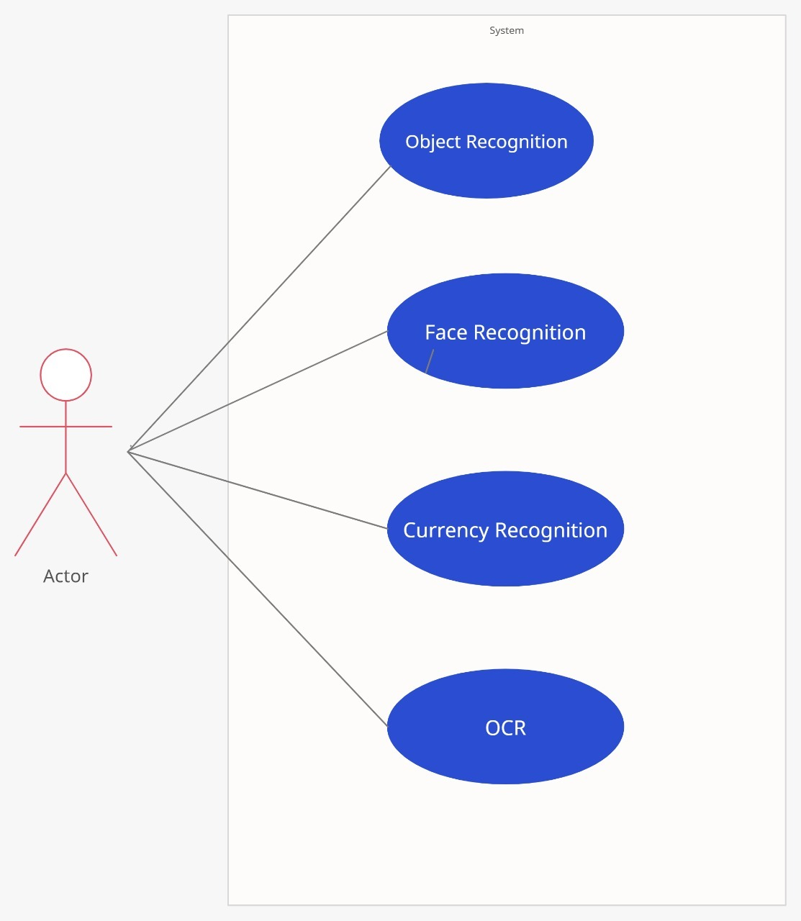

*Figure 12: Eye Guide Use Case diagram.*

The program consists of 4 major features which the user can choose from

Object Recognition, Face Recognition, Currency Recognition and OCR.

### 3.2.3 **Sequence Diagram**

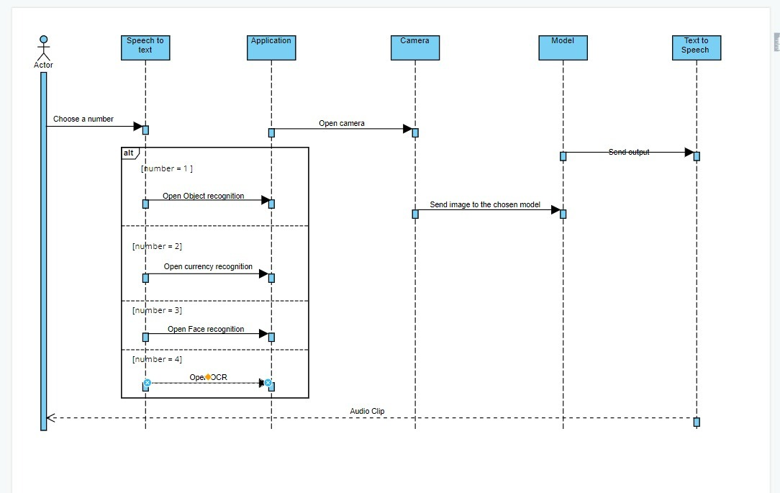

*Figure 13: EYE Guide Sequence diagram.*

The user opens the program and Google API (text to speech) starts to list the options. The user chooses a number using his voice (Speech to Text) depending on the feature he wants to use. The camera opens and the user takes a picture, The picture is sent to the chosen model. The output is sent to Google API (Text to Speech). The audio clips are played by the application.

# Implementation and Testing

In this chapter we will explain the implementation of each model separately.

1. **Object detection model.**

**Object Detection:**

We see the whole world through our eyes. It captures the image and send it to the brain who encodes the image and retrieve a lot of information, for example: the objects in the image who its place, and so many other information.

This interesting ability of the brain led the Research to think that what if we can give this ability to a machine. How many fields will it open, how many it will helps. So much can be done.

Well in that pursuit, there is one big hurdle. How do we make the machine to identify an object? That’s what gave rise to the domain of Computer Vision that we call “Object Detection”. Object detection is a field of Computer Vision and Image Processing that deals with detecting instances of various classes of objects (like a person, book, chair, car, bus, etc.) in a digitally captured Image or Video.

This domain is further divided into sub-domains like Face detection, Activity recognition, Image annotation, and many more. Object Detection has found its applications in various important areas like Self-Driving cars, robots, Video Surveillance, Object Tracking, etc.

**Challenges:**

1. Variable Number of Objects
2. Multiple Spatial Scales and Aspect Ratios
3. Modeling
4. Limited Data
5. Speed for Real-Time detection

There are various approaches for object detection like Fast R-CNN, Single Shot MultiBox Detector (SSD), Retina-Net, and finally YOLO (You Only Look Once). Yolo is an algorithm based on regression rather than selecting the interesting part of the image it predicts classes and bounding boxes for the whole image in one run of the Algorithm.

To understand the YOLO algorithm, first, we need to understand what is being predicted. Ultimately, we aim to predict a class of an object and the bounding box specifying object location. Each bounding box can be described using four descriptors:

1. Center of the box (bx, by).

2.Width (bw).

3. Height (bh).

4. Value corresponds to the class of an object.

5. The probability that there is an object in the bounding box (pc).

Yolo doesn’t only search for the interesting parts of the image that could contain the object, but he splits the image into a 19x19 grid. Each cell is then responsible for predicting K-bounding boxes.

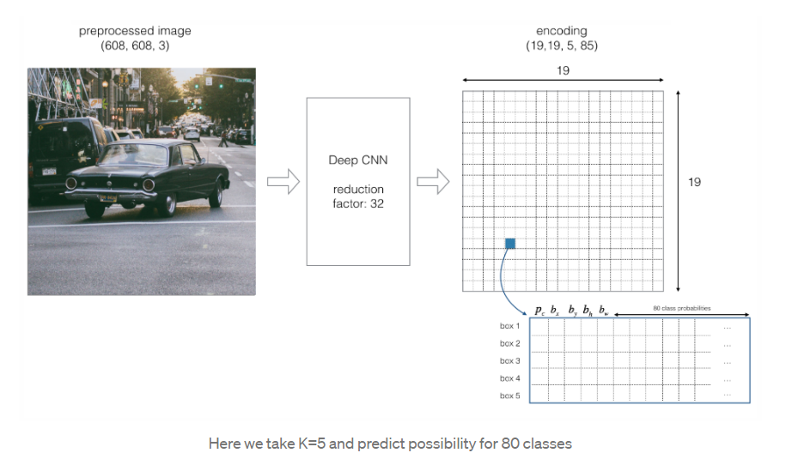

*Figure14: YOLO Convert image to grid.*

An object is only considered if the center if the object lies in the center of the cell Due to this property the center co-ordinates are always calculated relative to the cell whereas the height and width are calculated relative to the whole Image size.

During the one pass of forwards propagation, YOLO determines the probability that the cell contains a certain class. The equation for the same is:

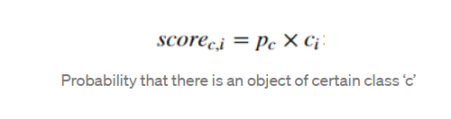

The class with the maximum probability is chosen and assigned to that cell. The process is repeated on every cell in the image.

After computing the probability is computed for all the cells, The image will look like this:

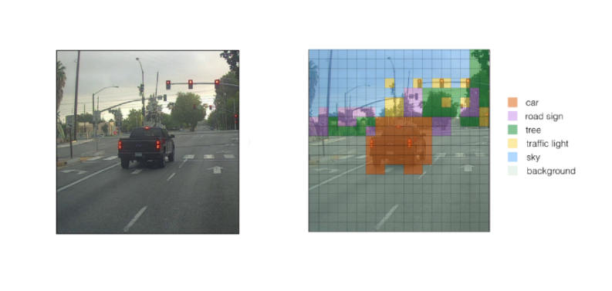

*Figure 15: YOLO Output grid.*

The next step is non-max suppression, which helps the algorithm to get rid of the unnecessary anchor boxes, like in the figure below where there are many anchor boxes around the same object

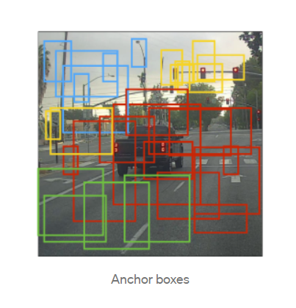

*Figure 16: Anchor grid.*

To resolve this problem, non-max suppression eliminates the bounding boxes that are very close by preforming the IoU (Intersection over Union) with the one having the highest-class probability among them.

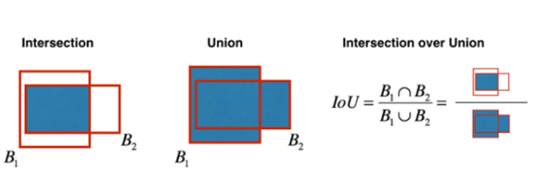

*Figure 17: IoU Operation.*

It calculates the value of IoU for all the bounding boxes respective to the one having the highest-class probability, it then rejects the bounding boxes whose value of IoU is greater than a threshold. It signifies that those two bounding boxes are covering the same object but the other one has a low probability for the same, thus it is eliminated.

Once done, the algorithm finds the bounding box with the next highest-class probabilities and does the same process, it is done until we are left with all the different bounding boxes.

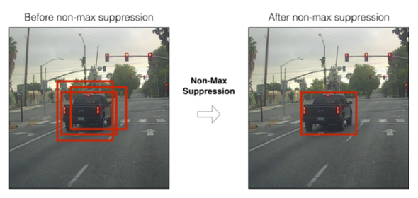

*Figure 18: Before and After non maximum suppression*

So, this was all about the YOLO Algorithm. We discussed all the aspects of Object detection along with the challenges we face in that domain. We then saw some of the algorithms that tried to solve some of these challenges but were failing in the most crucial one-Real time detection (speed in fps).

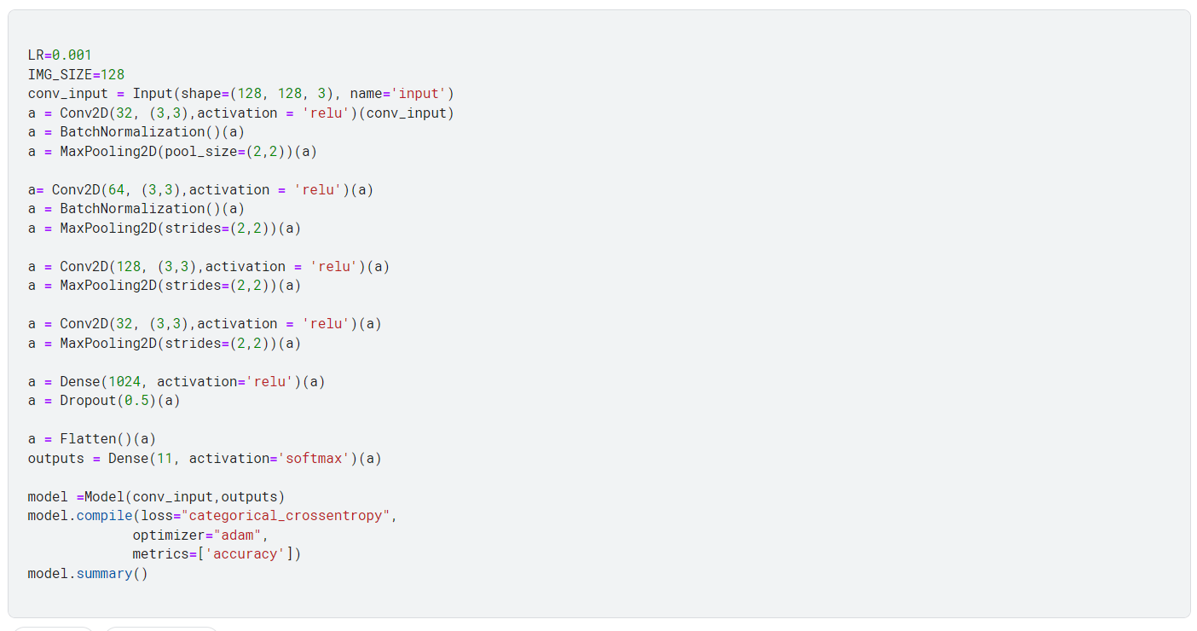

*Figure 19: Object detection Neural-Network Model.*

This is the neural network model used to calculate the weights use in the object detection model. The model consists of 6 layers, the first layer is a 2D Convolution layer with 32 filters, followed by a Batch normalization layer which maintains the mean output close to 0 and the variance close to 1, Then a 2D Max Pooling layer which down samples the dimensions (height and width) by taking the maximum value over an input window for each channel of the input. The window is shifted by strides along each dimension. The next layer consists of a 2D Convolution layer with 64 filters, Batch normalization, and 2D Max Pooling layers. The third layer is the 2D Convolution layer with 128 filters and a Max Pooling layer. The fourth layer is a 2D Convolution layer with 32 filters and a Max Pooling layer. The second to last layer consists of a Dense layer that connects all the layers to each other. The final layer is the output layer with the number of outputs expected. This model has an accuracy of 97%.

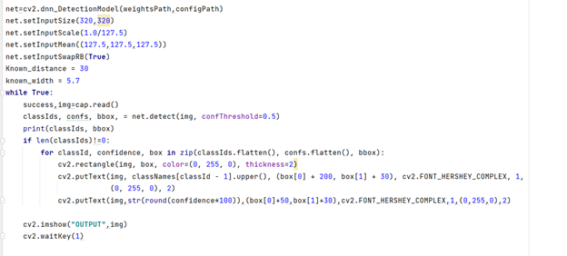

In this function. The program takes the input from the camera whether it is a video or an image and the weights from the previous model, the configuration path, and the threshold to find the class ID, confidence, and the bounding box. If the class ID doesn’t equal zero, then an object has been detected. using OpenCV, we draw a rectangle surrounding the box, the name of the object, and the confidence of this object.

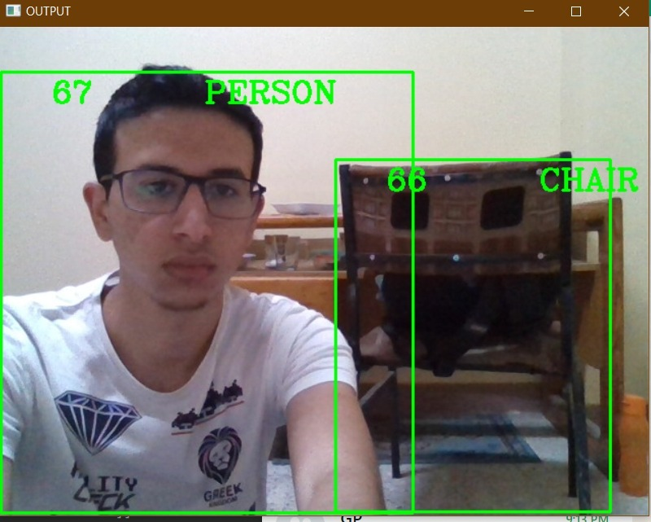

*Figure 20: Object detection Output examples.*

1. **Face Detection Model.**

Visualization is one of the main senses that a human mind depends on for the cognition function. By just looking at a person, your brain can recognize them in a very short period. AI and ML have always tried to mimic such an uncanny ability for many purposes over the last few years. In our application, we have implemented a modern technique including cmake, dlib, and face_recognition python libraries. Unlike many other features, face recognition is applied throughout an ordered sequence of different algorithms.

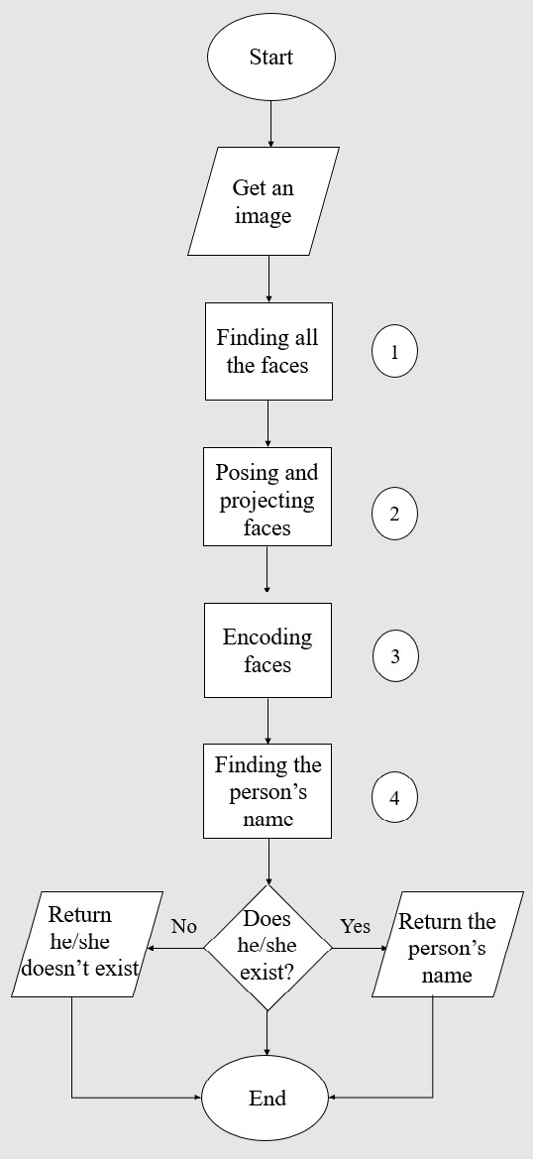

*Figure 21: Flowchart of face detection.*

When you open the application at first, you have the features screen. Then, you choose the ‘Face Recognition’ feature. The new screen, you’re navigated in, tells you that there is no image selected yet followed by a button with a centered text ‘Take a photo!’. When you pick a photo with the mobile camera, it’s encoded to base64 type, sent by a flask API to a local host on a particular laptop, decoded to its original form, and finally processed there by a pipeline of 4 steps.

**1.   Finding all the Faces:**

Detecting all faces in an image is the most first step at all. There are many invented ways for this purpose but the used one here is the HOG algorithm.

·   The image is turned into black & white because the color data isn’t needed.

·   For every single pixel of the image, we look at all the pixels surrounding it and replace it with an arrow showing in which direction the image is getting darker.

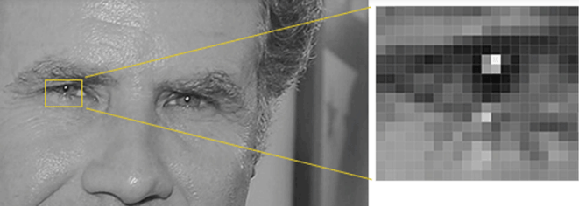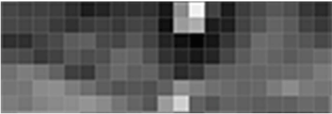

*Figure 22: Face detection technique.*

·   Due to ending up with too many arrows, which are called gradients, we just need the basic pattern of the image. So, the image is divided into 16x16 small squares. In each square, we are going to find the strongest arrows, which point only to major directions, and replace that square in the image.

·   Finally, we have the image in HOG representation and now we need to detect which part of the image is the most like the HOG pattern of a human face. This is how to detect a face in an image.

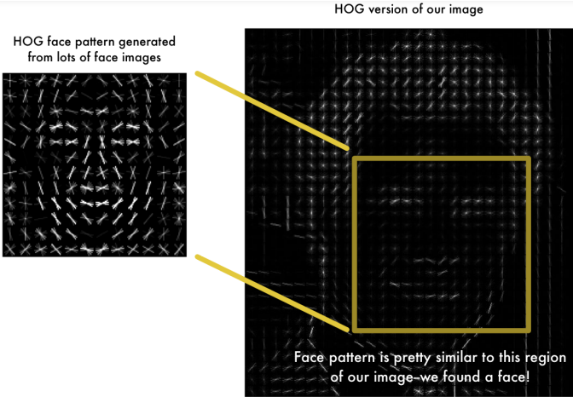

*Figure 23: HOG image.*

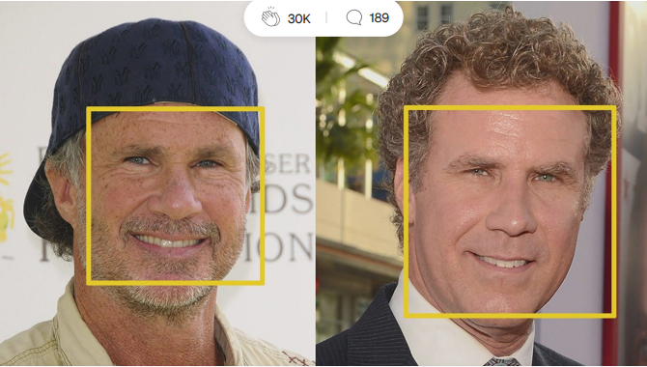

**2. Posing and Projecting Faces**

Now, we face the problem that images of the same person, but different directions look totally different to a computer. The solution is to make the eyes and lips always in the sample place in the image.

·   An algorithm called ‘face landmark estimation’ is used to extract 68 specific points, which are named as landmarks, out of the face in the image. Examples of these landmarks are the top of the chin, the edge of the eyebrow, etc.

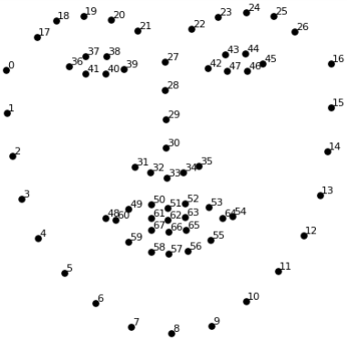

*Figure 24: Face detection output.*

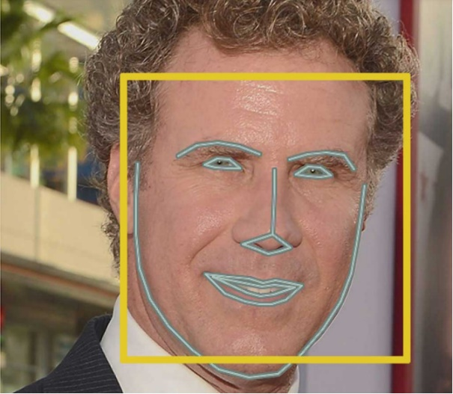

*Figure 25: detect eyes and lips.*

·   To make the eyes and lips centered in the image as proposed, we use some basic affine transformations including rotation, scaling, and shearing.

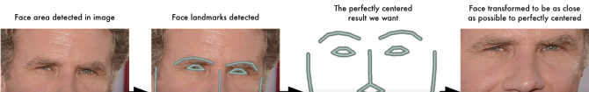

**3.   Encoding Faces**

Here we get into the kernel of our problem. The criteria on which we depend to distinguish a person’s face from another’s one is the measurement. We need to extract basic measurements for a face that represents something like DNA for a human. Researchers were confused about whether the ear size, the nose length, or any other face feature can be good. But they agreed that letting the computer train a CNN to find the best features is the best for this mission. After training for a long time with too many people, the result is getting 128 measurements out of a face.

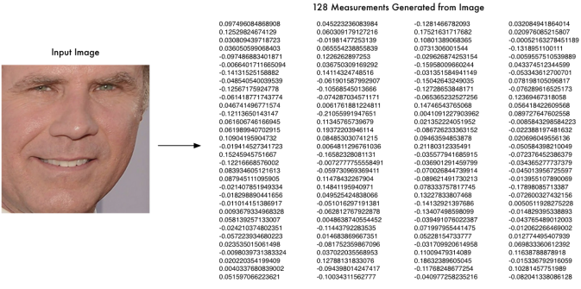

*Figure 26: Face encoding.*

**4.   Finding the person’s name from the encoding**

Moving to the last and easiest step, we compare the encoding of our image to the encoding of all images in the database. Many classifiers can be used here but we need just a simple one. So, the chosen one is the SVM classifier. The image with the encoding closest to the encoding of ours is the one we are seeking for.

After all the pipeline processes have taken place, the returned value with the flask API is the person’s name if he/she is found.

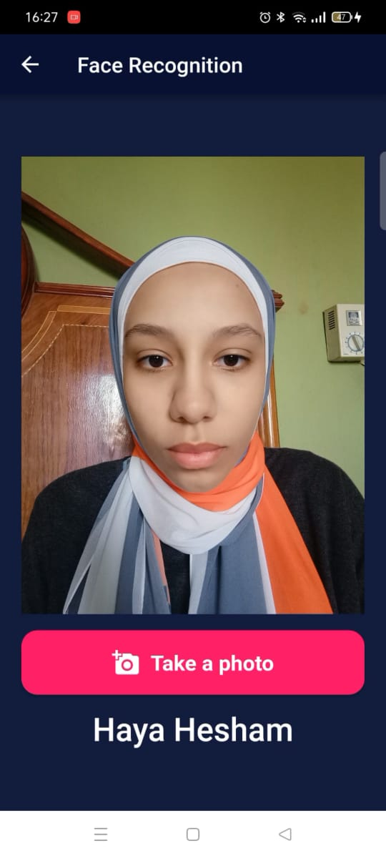

*Figure 27: Face detection Output.*

Otherwise, the application tells you that this face isn’t recognized, i.e., there is no photo of this person existing in the database. So, you are asked to enter his/her name, and then his/her photo is successfully saved.

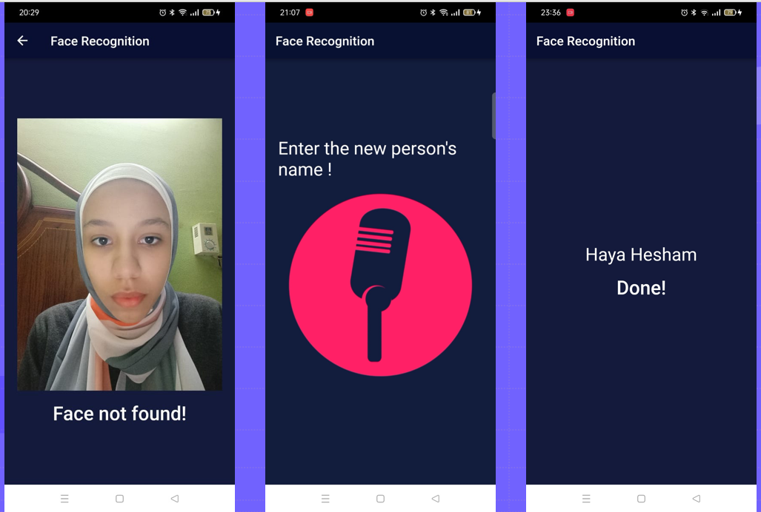

*Figure 28: Add a new person.*

Testing of this feature on an OPPO phone showed an excellent result in less than one minute!

1. **Currency Recognition Model**

Currency recognition is a very special feature as currency changes from one country to another. So, we need a distinct, separate model for every single currency. For implementing this feature, we have used a Kaggle dataset containing over 9000 images. It was the only dataset for Egyptian banknotes including 6 different classes: 5 EGP, 10 EGP, 20 EGP, 50 EGP, 100 EGP, and 200 EGP. For the ML model, we have used YOLOV5, which has been explained before, and CNN using google collab’s GPU.

CNN is a class of ANN that’s most applied for analyzing visual imagery. There are many types of NNs, but CNN is the most preferred one for image and object classification for many reasons including high accuracy, sparse connections which reduce overfitting rather than dense connections, parameter sharing, etc. But the most important reason is that feature engineering isn’t required. Before CNN, feature selection is an essential step for classification and for images, which are represented in lots of real numbers, it’s almost impossible to manually extract appropriate features. CNN does this task automatically by feature selectors called ‘filters’ that convolve the dataset images finding the best features throughout the backpropagation algorithm. The feature selection step is followed by the classification step which includes flattening the image matrix into a 1D vector and densely connecting it to an output layer that usually uses the SoftMax activation function.

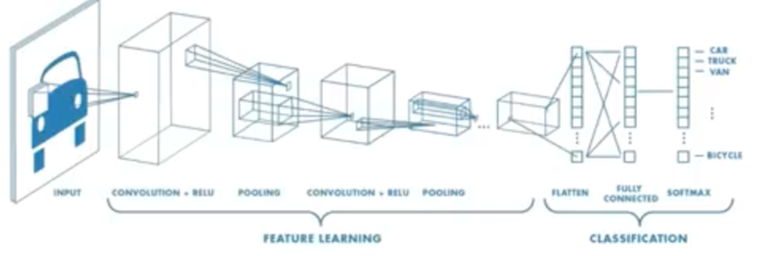

*Figure 29: CNN internal implementation.*

We split the dataset size so that the training set in 80% and the testing set to be the rest 20%. For compiling the model, we used mini-batch gradient descent with a batch of 16 samples, resized the images to be all of size 416x416, and then started the training process for 40 epochs using the YOLOV5 weights in terms of a technique TL.

Transfer learning (TL) is a research problem in machine learning (ML) that focuses on storing knowledge gained while solving one problem and applying it to a different but related problem. For example, knowledge gained while learning to recognize cars could apply when trying to recognize trucks. This area of research bears some relation to the long history of psychological literature on the transfer of learning, although practical ties between the two fields are limited. From a practical standpoint, reusing or transferring information from previously learned tasks for the learning of new tasks has the potential to significantly improve the sample efficiency of a reinforcement learning agent.

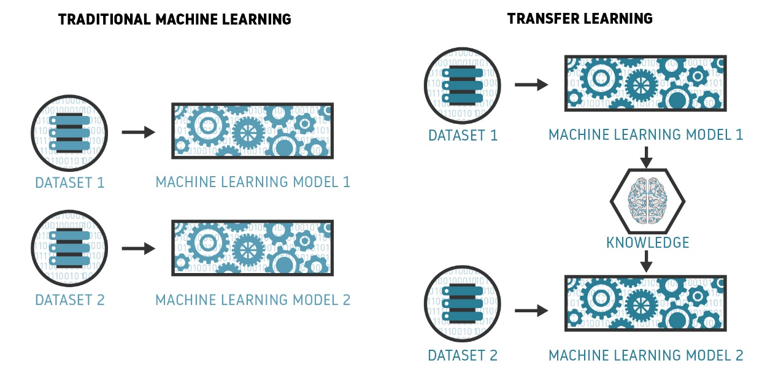

*Figure 30: Transfer Learning concept.*

Many evaluation metrics showed an excellent result and here are some of them:

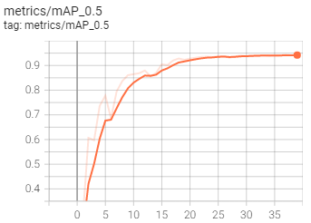

*Figure 31: Mean Average Precision.*

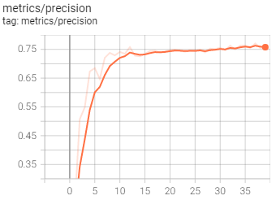

*Figure 32: Precision.*

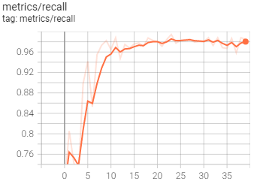

*Figure 33: Recall.*

During human test, the model could successfully classify all the banknotes we experimented which shows high accuracy. But unfortunately, it poorly can detect them.

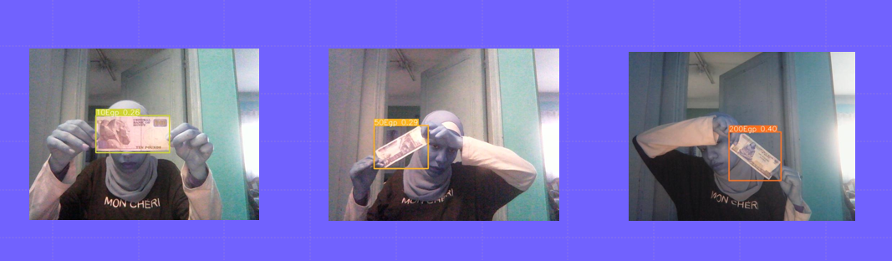

*Figure 34: Currency Recognition Output.*

1. **Optical Character Recognition (OCR)**

OCR is to extract the text from an image it is implemented using Tesseract.

Tesseract is an OCR engine developed to extract text from images

**How it works?**

1. OCR software converts the document into a two-color or black-and-white version.

2. The scanned-in image or bitmap is analyzed for light and dark areas, and the dark areas are identified as characters that need to be recognized, while light areas are identified as background.

3. The dark areas are then processed to find alphabetic letters or numeric digits.

4. This stage typically involves targeting one character, word, or block of text at a time. Characters are then identified using one of two algorithms — pattern recognition or feature recognition.

5. **Pattern recognition** is used when the OCR program is fed examples of text in various fonts and formats to compare and recognize characters in the scanned document or image file.

6. **Feature detection** occurs when the OCR applies rules regarding the features of a specific letter or number to recognize characters in the scanned document.

7. **Features include** the number of angled lines, crossed lines, or curves in a character. For example, the capital letter “A” is stored as two diagonal lines that meet with a horizontal line across the middle. When a character is identified, it is converted into an ASCII code (American Standard Code for Information Interchange) that computer systems use to handle further manipulations.

Results on the PC

*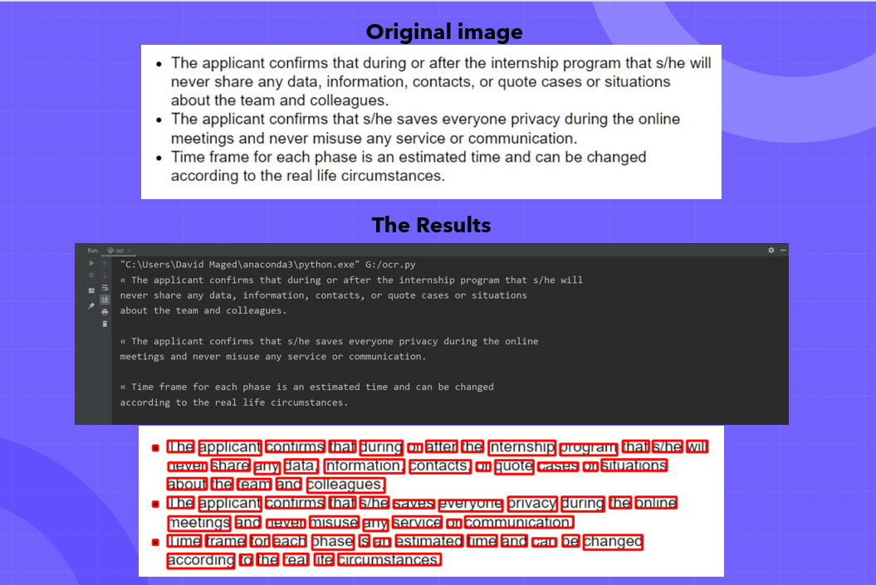 Figure 35: OCR input and output.*

# User Manual

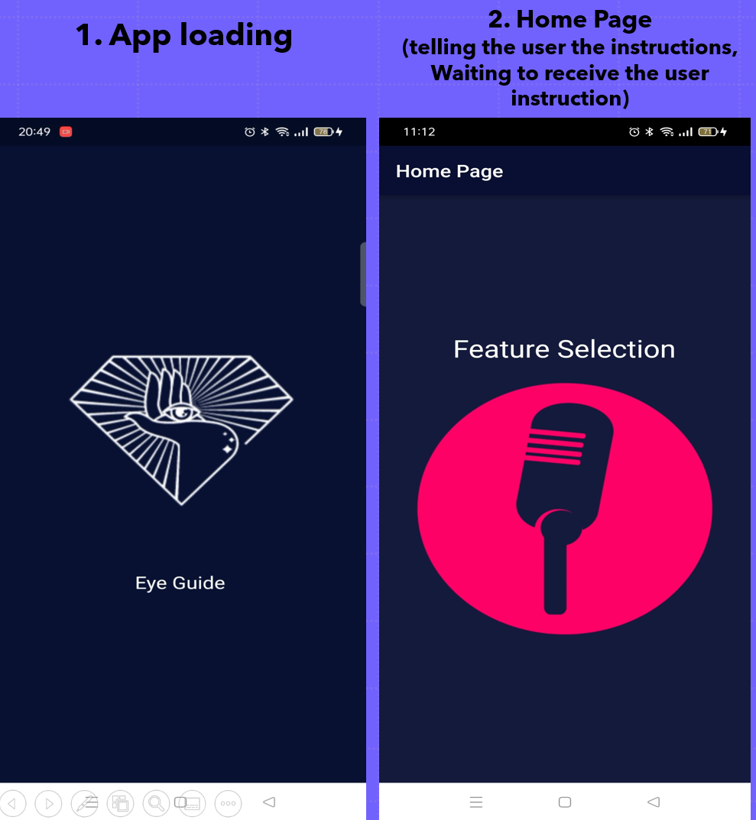

*Figure 36: Eye Guide home Screen*

**Results**

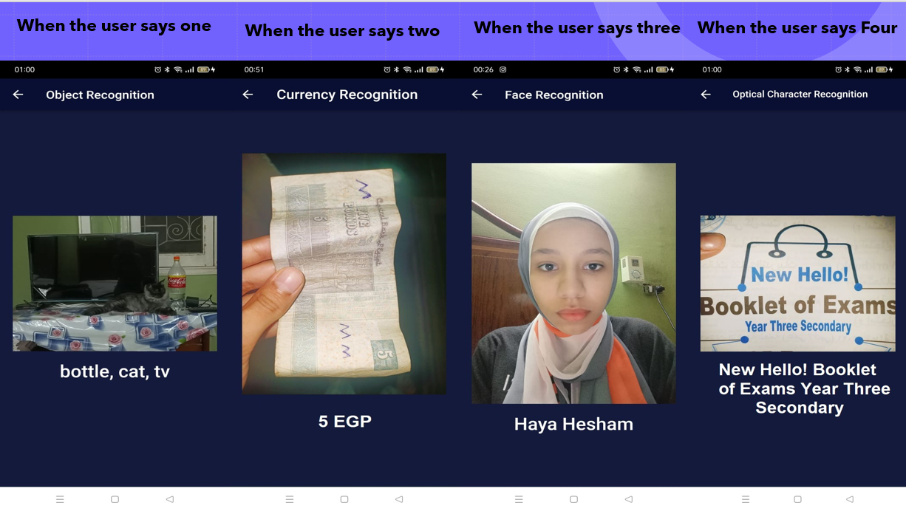

*Figure 37: Eye Guide Models Screen*

# Conclusion and Future Work

## **6.1 Conclusion**

For visually blind people life is so hard, our project is used to make their life a little bit easier and help them with their everyday tasks. That’s why we build the object detection model with 97% accuracy so it would be easy to identify the unfamiliar object. The face recognition model helps to recognize people more easily with 95% accuracy. The currency recognition model helps exchange money and be freer and more independent. Our project could help them visualize the world and could be the modern stick they use without using their hands.

## **6.2 Future Work**

Our target is to make one app that has all services that the blind people want to implement in their daily tasks without needing any other person.

This is the **first version** of the EYE Guide app; it will be available soon on Google Play.

In future work, we will add the two most important features to the **second version**

1. **Guidance Feature:**

Guidance Feature will help them move in the street safely, it will use the object detection model to make him/her avoid obstacles in the street.

**The implementation** of this feature will be done by splitting the frame into 3 parts, left, center, and right.

Then we will take the moving decisions depending on the bounding boxes generated by the object detection model, after this, we will calculate the distance between the user and the obstacle in feet’s using the focal length algorithm and a threshold will be taken to warn the user if an obstacle is near him/her.

What if the three frames have bounding boxes?

It is a logical problem, It Will be solved when the user moves forward the frame will zoom in automatically. So, some bounding boxes hide automatically.

**How focal length algorithm works?**

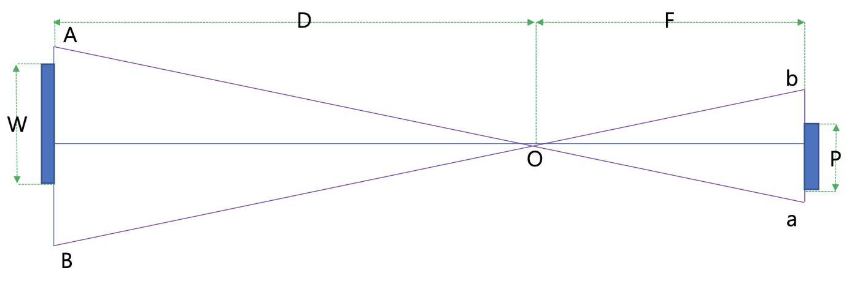

*Figure 38: Focal Length Representation.*

Point O: is where the camera’s lenses are.

*AB:* is where the actual object is located.

*Ab:* is the image of the object appearing on the camera.

𝑊∶𝐷=𝑃∶𝐹 (1)

𝐷=𝑊×(F/P) (2)

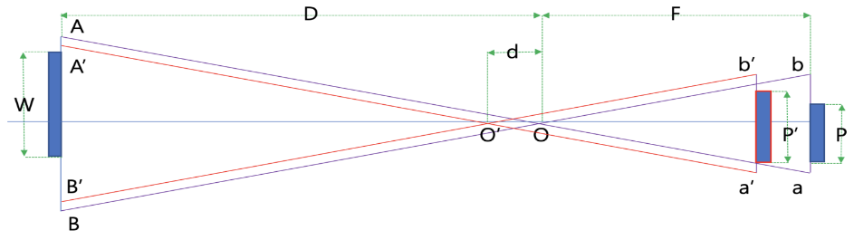

*Figure 39: Focal Length algorithm.*

𝑃′>𝑃 (3)

𝑊∶(𝐷−𝑑) = 𝑃’: 𝐹 (4)

𝐷=𝑑+𝑊*(F/P’) (5)

Using equations 2 and 5, the following equation can also be inferred.

𝐷=𝑑*(P’/(P’-P)) (6)

1. **Image caption Feature:**

How will it be implemented?

The coco dataset has a caption for each image, a model will be trained on this dataset and the result will be as these photos.

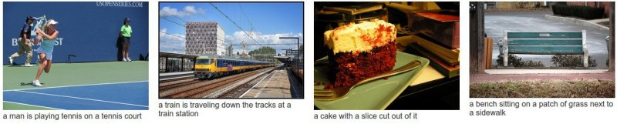

*Figure 40: Image Captioning model.*

# References

1. Takeda, F. and Omatu, S., 1995. High speed paper currency recognition by neural networks. *IEEE Transactions on Neural Networks*, *6*(1), pp.73-77.
2. Hassanpour, H., Yaseri, A. and Ardeshiri, G., 2007, February. Feature extraction for paper currency recognition. In *2007 9th International Symposium on Signal Processing and Its Applications* (pp. 1-4). IEEE.
3. Riesenhuber, M. and Poggio, T., 2000. Models of object recognition. *Nature neuroscience*, *3*(11), pp.1199-1204.
4. Papageorgiou, C. and Poggio, T., 2000. A trainable system for object detection. *International journal of computer vision*, *38*(1), pp.15-33.
5. Zhao, Z.Q., Zheng, P., Xu, S.T. and Wu, X., 2019. Object detection with deep learning: A review. *IEEE transactions on neural networks and learning systems*, *30*(11), pp.3212-3232.
6. Smith, R., 2007, September. An overview of the Tesseract OCR engine. In *Ninth international conference on document analysis and recognition (ICDAR 2007)* (Vol. 2, pp. 629-633). IEEE.
7. Memon, J., Sami, M., Khan, R.A. and Uddin, M., 2020. Handwritten optical character recognition (OCR): A comprehensive systematic literature review (SLR). *IEEE Access*, *8*, pp.142642-142668.
8. Holley, R., 2009. How good can it get? Analysing and improving OCR accuracy in large scale historic newspaper digitisation programs. *D-Lib Magazine*, *15*(3/4).
9. Patel, C., Patel, A. and Patel, D., 2012. Optical character recognition by open source OCR tool tesseract: A case study. *International Journal of Computer Applications*, *55*(10), pp.50-56.
10. Zhao, W., Chellappa, R., Phillips, P.J. and Rosenfeld, A., 2003. Face recognition: A literature survey. *ACM computing surveys (CSUR)*, *35*(4), pp.399-458.
11. He, X., Yan, S., Hu, Y., Niyogi, P. and Zhang, H.J., 2005. Face recognition using laplacianfaces. *IEEE transactions on pattern analysis and machine intelligence*, *27*(3), pp.328-340.
12. Jafri, R. and Arabnia, H.R., 2009. A survey of face recognition techniques. *journal of information processing systems*, *5*(2), pp.41-68.
13. Redmon, J., Divvala, S., Girshick, R. and Farhadi, A., 2016. You only look once: Unified, real-time object detection. In *Proceedings of the IEEE conference on computer vision and pattern recognition* (pp. 779-788).
14. Huang, R., Pedoeem, J. and Chen, C., 2018, December. YOLO-LITE: a real-time object detection algorithm optimized for non-GPU computers. In *2018 IEEE International Conference on Big Data (Big Data)* (pp. 2503-2510). IEEE.
15. Du, J., 2018, April. Understanding of object detection based on CNN family and YOLO. In *Journal of Physics: Conference Series* (Vol. 1004, No. 1, p. 012029). IOP Publishing.
16. Fang, W., Wang, L. and Ren, P., 2019. Tinier-YOLO: A real-time object detection method for constrained environments. *IEEE Access*, *8*, pp.1935-1944.
17. Liu, C., Tao, Y., Liang, J., Li, K. and Chen, Y., 2018, December. Object detection based on YOLO network. In *2018 IEEE 4th Information Technology and Mechatronics Engineering Conference (ITOEC)* (pp. 799-803). IEEE.
18. Shafiee, M.J., Chywl, B., Li, F. and Wong, A., 2017. Fast YOLO: A fast you only look once system for real-time embedded object detection in video. *arXiv preprint arXiv:1709.05943*.
19. Brady, E., Morris, M.R., Zhong, Y., White, S. and Bigham, J.P., 2013, April. Visual challenges in the everyday lives of blind people. In *Proceedings of the SIGCHI conference on human factors in computing systems* (pp. 2117-2126).
20. Haykin, S., 2009. *Neural networks and learning machines, 3/E*. Pearson Education India.
21. Goodfellow, I., Bengio, Y. and Courville, A., 2016. *Deep learning*. MIT press
22. Aggarwal, C.C., 2018. Neural networks and deep learning. *Springer*, *10*, pp.978-3.

**Project URL**

**Scan this code**

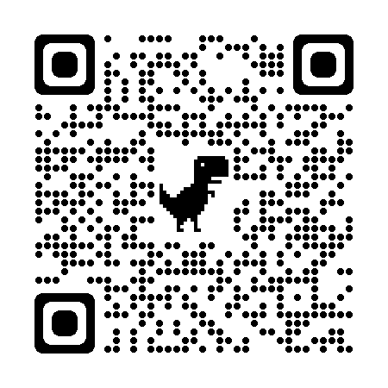

*Figure 41: Project URL.*